**[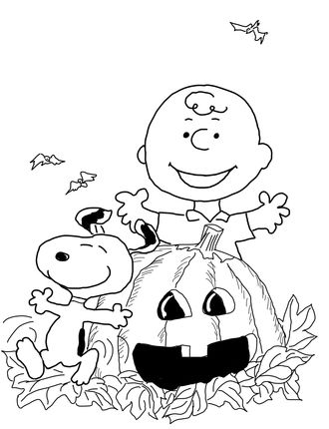](http://www.supercoloring.com/pages/charlie-brown-halloween)**

Bring coloring page with on October 7th for a chance to win a prize!

Name: Age: