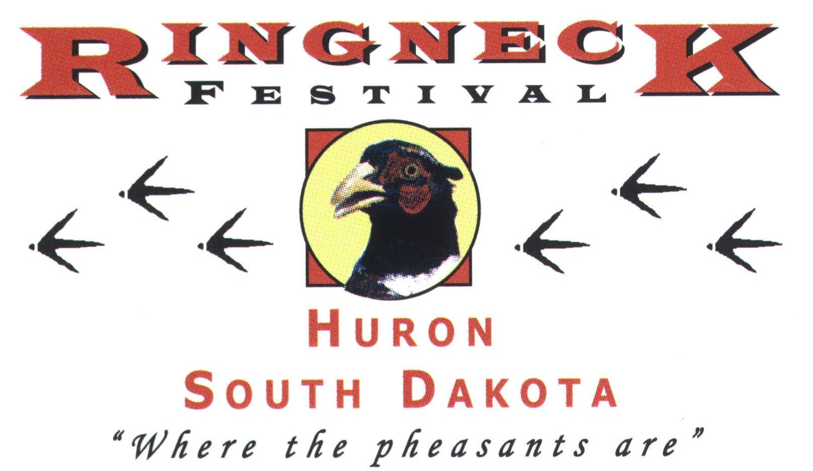

Huron Chamber & Visitors Bureau
1725 Dakota Ave S • Huron, SD 57350
(605) 352-0000
www.hunthuronsd.com or email: program.events@huronsd.com

2024
Ringneck Festival and Bird Dog Challenge Volunteer Scholarship

For:
Past volunteers or direct family members of volunteers of the 2023 Ringneck Festival and Bird Dog Challenge

Scholarship Information and Criteria

Instructions for completing this application – please read carefully:
- Complete all parts of the application and attach a copy of your unofficial transcript (high school, college or certification program).
- Submit this application form and a copy of your unofficial transcript by 5:00 pm, April 15, 2024 to the following address. Postal applications must be postmarked by this date while fax and email copies must be date stamped sent by this date:
Mail: Huron Chamber & Visitors Bureau
1725 Dakota Ave S
Huron, SD 57350
Email: program.events@huronsd.com
- Late/incomplete applications will not be considered unless there are no other eligible applicants.
- If completing your application online, mail or fax a copy of your unofficial transcript to the above address or number by the above deadline.

Eligibility Rules and Disclaimers:
- Up to $2,000 in scholarship funds may be available
- An applicant must either be a volunteer or be a direct family member of a volunteer or landowner involved in the 2023 Ringneck Festival and Bird Dog Challenge. (Direct family member is defined as a spouse, sibling, parent or grandparent)
- An applicant must be currently in good standing (“C” average or better) at a high school or an accredited college or qualified technical institute.
- The scholarship committee reserves the right to provide one or more scholarships, in varying amounts, to qualified applicants.
- If there are no qualified applicants, the scholarship committee will forego providing scholarships.
- Failure to acknowledge acceptance of the award will result in award forfeiture.
- Scholarship funds are divided between the fall and spring semesters and paid directly to the recipient’s institution. The final payment will be forfeited if the recipient has withdrawn from the program.
- If a recipient graduates in December, he/she must provide written proof of this fact and then he/she will receive all of the scholarship funds in the fall semester.
- Falsification of information or violation of rules will result in withdrawal of all remaining scholarship funds.

Scholarship Application

Full Name_____________________________________________________________________

Address______________________________________________________________________

City _____________________________State ___________________Zip _________________

Cell Phone ____________________________

Name of Volunteer & Relationship________________________________________________

Your Volunteer Involvement in the 2023 Ringneck Festival
______________________________________________________________________________

______________________________________________________________________________

______________________________________________________________________________

High School or Post-Secondary Cumulative GPA __________

University or Technical Institute attending (Name and Financial aid mailing address)

_______________________________________________________________________

Scholarships or Financial Aid Received ___________________________________________

- Did you receive a Federal Pell Grant or a Subsidized Loan this year? _________

Intended Major in College ______________________________________________________

List All Employment during High School and/or College

______________________________________________________________________________

______________________________________________________________________________

Use additional pages if needed and attach to this form:

- List all awards or special recognition received during high school and/or college.

- List all participation in extra-curricular school activities, leadership positions held and number of years you participated (athletics, music, cheerleading, clubs, class officers, etc.)

- List your outside activities during high school and/or college (4-H, FCCLA, or FFA, Scouts, Church, etc.), length of participation, and any leadership roles you have held.

- Briefly describe how you have participated in your community and why you feel such participation is important.

- Briefly describe the ways the Ringneck Festival has helped benefit the Huron area.

Please attach a written reference from one community leader or teacher.

Name __________________________ Phone Number________________________

Please attach a copy of your grade transcripts.

By signing, I:
- Authorize the Huron Chamber & Visitors Bureau to contact my educational institution for additional information and to determine my enrollment status.
- Authorize the use of my name and image for use in advertising and press releases announcing my award.
- Agree to use the scholarship funds for the purpose of obtaining my degree or certification.

I attest, to the best of my knowledge, this application to be accurate and truthful.

Signature Date

