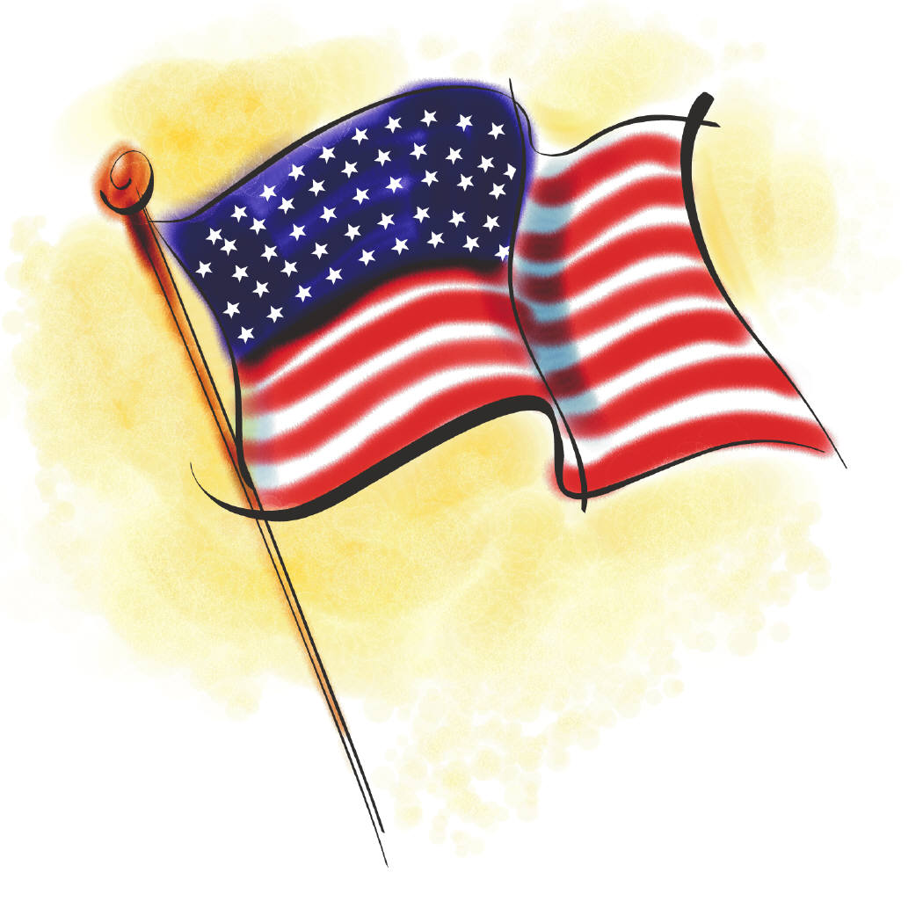

________________________________________________________________________________
Independence Day Celebration
Vendor Fair

July 4, 2025  Campbell Park, Huron, SD

The Huron Chamber & Visitors Bureau is planning an Independence Day Celebration. Activities include a parade, BBQ, entertainment and of course, the Vendor Fair. Please mark your calendar and if you are interested in participating, please fill out the attached form and return it with your registration fee of $15 by June 15, 2025.

Date: July 4, 2025 Location: Campbell Park
Show Hours: 10am-2pm (Dakota Ave, between 5th and 7th street)

Outdoor Vendors: $15 includes 20’x20’ space (tables not included)

Hold Harmless Agreement: Participants will be required to purchase and sign a “Hold Harmless Agreement” in the amount of $1 from the Huron Chamber & Visitors Bureau. The $1.00 is included in your entry fee.

Security: All participants will be responsible for their own security.

Name: ________________________________________ Phone: ______________________

Address: ________________________________________ Email: _______________________
________________________________________

Spaces needed: _______ ($15 per booth)
Total Entry fee: $______________

Make checks to the Huron Chamber & Visitors Bureau
Send Registration to the Huron Chamber & Visitors Bureau
1725 Dakota Ave. S., Huron, SD 57350
If you have any questions contact the Chamber & Visitors Bureau at
605-352-0000 or e-mail: membershipservices@huronsd.com

Independence Day Celebration
Vendor Fair & Parade
July 4th, 2025

Hold Harmless Agreement

I, __________________________________, city of Huron, State of South Dakota, for myself and my heirs, legal representatives and assigns, in consideration of the sum of One Dollar ($1.00) and other good and valuable consideration to me paid to the Huron Chamber & Visitors Bureau, receipt of which is hereby acknowledged. Agreement with said Huron Chamber & Visitors Bureau of 1725 Dakota Ave. S., City of Huron, County of Beadle, State of South Dakota, its heirs, legal representatives and assigns, to never institute, prosecute or in any way aid in the institution or prosecution of any claim, demand, action, or cause of action for damages, costs, loss of services, expenses, or compensation for or on account of any damage, loss or injury either of person or property, or both, whether developed or undeveloped, resulting or to result, known or unknown, past, present or future, arising out of:

Independence Day Celebration
Flea Market & Parade
July 4th, 2025

In executing this agreement, I expressly reserve any and all right, causes of action, claims and demands against any person, firm or corporation including the Huron Chamber & Visitors Bureau.

Executed at Huron, South Dakota, on this ____ day of __________________, 2025.

Print Name: _____________________ Signature: __________________________

By signing this agreement, I understand that I am responsible for maintaining clean up of my float and/or responsible for maintaining the garbage in my area, adhere to the hours of the Vendor Fair Market and adhere to all items mentioned in the above paragraphs.

