YOUR

WEDDING DAY

AT THE
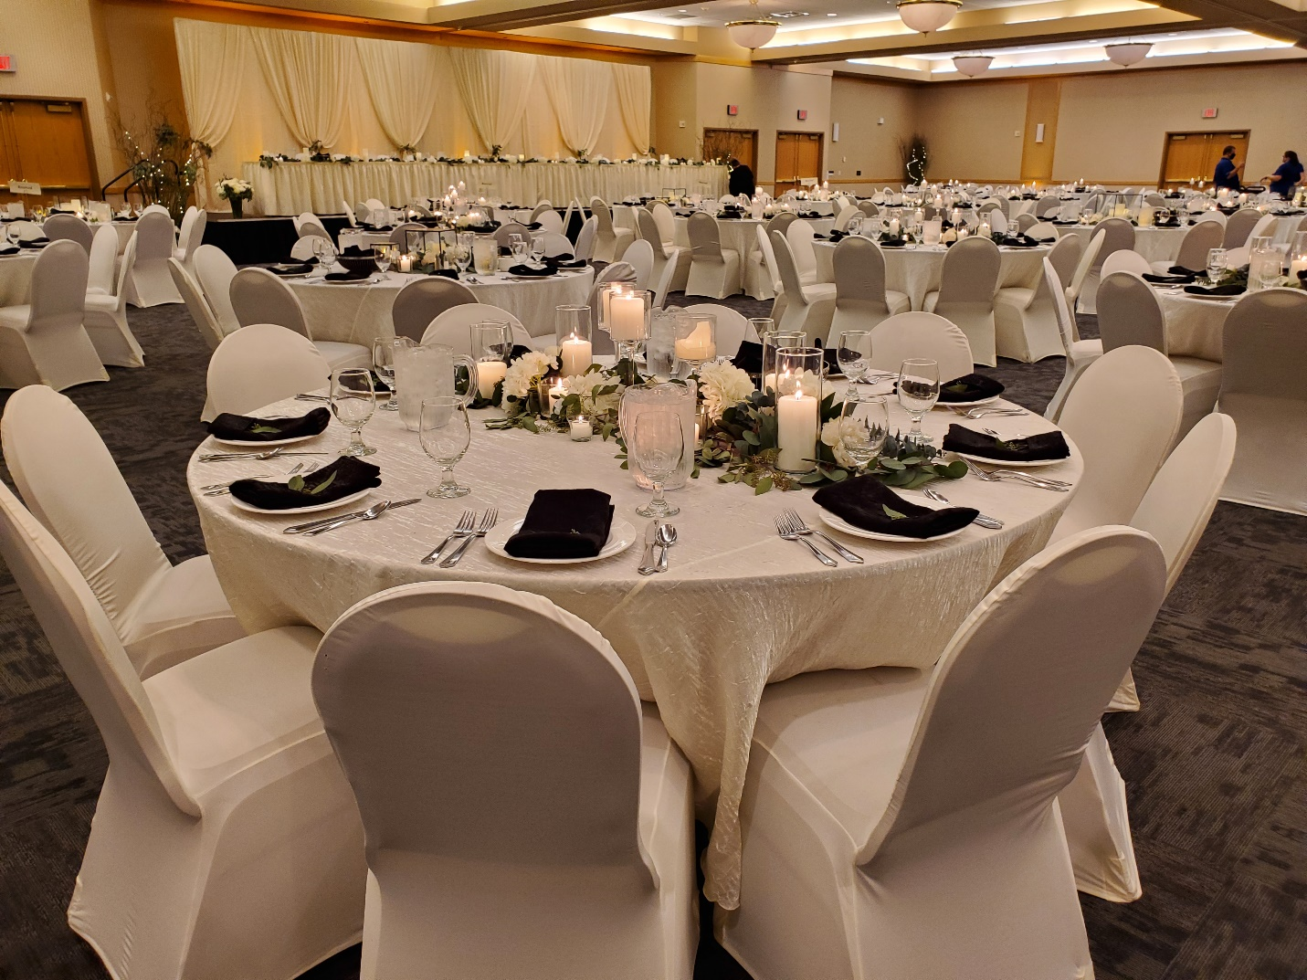HURON EVENT CENTER

Huron Event Center
501 Wisconsin Avenue SW • Huron, SD 57350
605-554-0239
www.huronsd.com
Huron Event Center
100 4th Street SW • Huron, SD 57350 • 605-352-3204
www.huroneventcenter.com
Huron Event Center
100 4th Street SW • Huron, SD 57350 • 605-352-3204
www.huroneventcenter.com
Huron Event Center
100 4th Street SW • Huron, SD 57350 • 605-352-3204
www.huroneventcenter.com
Huron Event Center
100 4th Street SW • Huron, SD 57350 • 605-352-3204
www.huroneventcenter.com

Congratulations on Your Engagement!

As you plan your guest list, your wardrobe, and all the other details of this joyous event,
let the Huron Event Center staff assist you in planning an unforgettable wedding reception.

Whether it’s an intimate family gathering or a large social event, every reception
will enjoy the same impeccable service and creative menu planning. Our catering professionals are versed in the subtleties of wedding etiquette, leaving no detail overlooked.

Your Wedding Package includes: $350.00 Ballroom Rental
• Serving Bowls for Nuts
• Punch Bowl and Ladle or Punch Fountain upon Availability
• Beverage Napkins
• Complete Set-up of Room with Tables, Chairs, White Tablecloths
• Standard Centerpieces and Mirror Tiles
• Gold Candles • Mosaic Candle • Red Hurricane Candle
• Skirting for All Appropriate Tables (Ivory or Black)
• China, Flatware, Glassware
• Linen Tablecloths – your choice of colors:
• White • Ivory • Burgundy • Hunter Green
• Silver • Beige • Black (extra charge)
• Floor Length White Table clothes (extra charge)
• Linen Napkins in a Variety of Colors for Dinner Service
• White • Ivory • Burgundy • Hunter Green
• Black • Brown • Red • Navy • Charcoal Grey
• Additional colors are available at extra charge
• Additional napkin fold options at extra charge
• PA System
• Staging for Head Table
• Dance Floor (extra charge for dance floor in middle of room)

Dakota Ballroom or Prairie Ballroom Rental Charge - $350.00

Additional Rental Items & Services:
• Cake Serving Service $50.00
• Back Drop behind Head Table $100.00
• Tri-Fold Lattis $25.00 each
• Charger Plates $.25 per plate
• Silver • Gold • Red
• Chair Covers $1.75 per chair (you install) • Black • Ivory • White $2.75 per chair (HEC install)
• Colored Bows - $1.00 each
• Served Head Table - $2.50 per person
• Popcorn/ Candy/Smores/Chips Station Clean Up Fee - $100.00
• Dance Floor set up in middle ballroom - $100.00
• Additional charges may be applicable if additional clean-up is required

Wedding Buffet Presentations

Buffet

Cocktail Sandwiches
Choice of Ham – Beef or Turkey (2 per person)

Choice of 2 Salads:
Homestyle Potato Salad, Creamy Coleslaw, Ambrosia Salad,
Italian Pasta Salad, Macaroni & Pea Salad, Taco Pasta Salad,
Herbed Orzo & Lemon Salad, Black Bean Salad, or Tossed Salad with Assorted Dressings

Market Fresh Vegetable Display with Ranch Dip

Fresh Fruit Display served with Yogurt Dipping Sauce – Add’l $1.75 per person

Kettle Potato Chips & Dip
Coffee, Decaf or Tea and Fruit Punch

$13.95 per person

Buffet

Pulled Pork BBQ Sandwiches (2 per person)

Choice of 1 Salad: Homestyle Potato Salad, Creamy Coleslaw,
Ambrosia Salad, Italian Pasta Salad, Macaroni & Salad, Taco Pasta Salad,
Herbed Orzo & Lemon Salad, Blacked Bean Salad
Additional Salad - $1.00 per person

Baked Beans Pickle Spears BBQ Sauce Kettle Potato Chips
Coffee, Decaf or Tea and Fruit Punch

$15.95 per person

All prices subject to applicable taxes and 18% gratuity.

Listed prices subject to change

Prices during COVID maybe subject to increase

Wedding Buffet Presentations

Dinner Buffet
Includes your selection of two Salads,
Vegetable, Potato, Fresh Baked Dinner Rolls,
Coffee, Decaf or Tea and Fruit Punch.

Salads
(Select two salads)
Creamy Coleslaw, Home-style Potato Salad, Italian Pasta Salad, Taco Pasta Salad,
Pea Salad, Ambrosia Salad, Tossed Salad with Assorted Dressings,
Herbed Orzo & Lemon Salad, Black Bean Salad, Cucumber Salad (seasonal)
Seasonal Mixed Fruit $1.50 additional

Choice of Vegetable
Green Beans Almondine, Glazed Carrots, Buttered Corn, Peas
Vegetable Medley or Peas & Carrots

Choice of Potato
Mashed Potatoes with Gravy, Baked Potato,
Au gratin, Scalloped or Parsley Buttered Potatoes

Dinner Buffet Entrées
Your Choice of One Entree $ 16.95/adult - $8.50/children
Your Choice of Two Entrees $19.95/adult - $11.00/children
** Entrees Additional $1.00

Roasted Pork Loin with Mushroom Marsala Sauce
Oven Roasted Chicken
**Roasted Turkey with Stuffing and Gravy

Roasted Round of Beef
Chicken Marsala with Mushroom Sauce

Chicken Divan topped with Broccoli Cream Sauce
Chicken Almondine
Lasagna
Honey Glazed Ham

Chef Carved Prime Rib of Beef with AuJus – Market Price
Additional Entrée – additional $2.00 per person

All prices subject to applicable taxes and 18% gratuity.Listed prices subject to change

Prices during COVID maybe subject to increase

Plated Dinners
All Silver Plated Dinners are served with wedding house salad bowl,
potato, and vegetable. Fresh Baked Dinner Roll, Coffee, and Fruit Punch are included.

(There will be a $1.50 per plate charge for plated dinners
when serving more than one entrée choice)

Beef Pot Roast
Tender oven roasted beef served with AuJus $17.95

Roasted Turkey & Dressing
Oven roasted turkey served with dressing and pan gravy.
$19.95

Chicken Almondine
Chicken breasted sautéed in a light cream sauce with muchrooms, celery,
onions and roasted almonds. $16.95

Boneless Stuffed Pork Chop

Stuffed boneless pork chop with stuffing and pork pan sauce.
$18.95

Bacon Wrapped Fillet
Hand cut 7oz broiled to medium and served with peppercorn sauce. Market Price

Roasted Prime Rib of Beef
USDA Prime choice beef.
Carefully slow roasted to a tender & juicy medium.
Topped with a delicious AuJus.
Market Price

Ribeye Steak
10oz Ribeye steak hand cut and broiled to medium.
Served with choice of herb butter or sautéed mushrooms.
Market Price

Lasagna Bolognese
Made fresh daily, a delicious combination of beef and Italian sausage mixed with creamy ricotta and mozzarella cheese. Finished with a hearty red sauce and Parmesan cheese.
Served with a garlic bread stick.
Served with NO potato or vegetable.
$17.95

Chicken Florentine
Chicken Breast stuffed with spinach and cheese.
Baked and topped with a white moray sauce. $16.95

Chicken Divan
Chicken breast topped with broccoli cream sauce
$16.95

Roasted Pork Loin
Oven roasted pork loin with marsala mushroom gravy. $16.95

Chicken Marsala
Sautéed chicken breast with mushroom marsala sauce $16.95

SALAD:
Wedding House Salad – mixed salad greens, grated mozzarella cheese, tomato wedges, black olives, cucumber slice, and salami. Served with vingarette dressing. This salad is served family style.

POTATO CHOICES: VEGETABLE CHOICES:
Parsley Buttered Potato Green Beans Almondine
Mashed Potato with Gravy Glazed Carrots
Baked Potato Buttered Corn
Au gratin Potato Vegetable Medley
Scalloped Potato Peas & Carrots
Peas

All prices subject to applicable taxes and 18% gratuity

Listed prices subject to change

Prices during COVID maybe subject to increase

Hors D’oeuvre Buffet Presentations

Chilled Hors D’ oeuvres

Deviled Eggs (2 per person) $1.50 per person
Silver Dollar Sandwiches (Ham, Beef or Turkey) $1.75 each
Assorted Deluxe Cold Cap apes (2 per person) $2.75 per person
Chilled Jumbo Shrimp with Cocktail Sauce (2 per person) $5.75 per person
Assorted Cheese & Crackers $2.50 per person
Assorted Meat Cheese & Crackers $3.75 per person
Fresh Fruit Display served with Yogurt Dipping Sauce $3.00 per person
Potato Chips, Pretzels & Dip $2.00 per person
Fresh Vegetables served with Creamy Dill Dip $2.75 per person
Spicy Crab Brochettes (2 per person) $3.25 per person

Hot Hors D’oeuvres

Barbequed Cocktail Franks (3 per person) $2.00 per person
Swedish or Meatballs (3 per person) $2.25 per person
Teriyaki or Buffalo Chicken Wings (2 per person) $4.25 per person
Spinach Artichoke with Dip & Toast Points $3.25 per person
Taco Plate $1.75 each

All prices subject to applicable taxes and 18% gratuity

Listed prices subject to change

Prices during COVID maybe subject to increase
Desserts

Buffet Dessert Selections

Assorted Bistro Cakes
Lemon Layer • Tiramisu • Red Velvet
$4.75 per person

New York Style Cheesecake with assorted toppings
Strawberry • Cherry • Chocolate • Caramel
$4.75 per person

Texas Brownies - $2.25 per person

Apple Crisp - $2.50

Assorted Fruit Pies
Apple • Cherry • Peach • Strawberry • Rhubarb • Pumpkin
$3.50 per person

Assorted Bars - $2.50 per person

Chocolate Fondue Full Package
Strawberries (3 per person)
Pineapple (4 per person)
Cream Puffs • Graham Crackers • Marshmallows • Pretzels
$7.95 per person

Chocolate Fondue Light Package
Strawberries (3 per person)
Graham Crackers • Marshmallows • Pretzel
$5.95 per person

Chocolate Fondue with Strawberries
Strawberries (3 per person)
$4.95 per person

Chocolate Fondue with Strawberries
Strawberries (5 per person)
$5.95 per person Available in Season Only

Cocktails Wine & Beer

Beverages
Freshly Brewed Coffee, Decaf or Hot Tea (per gallon) $14.00
Fruit Punch, Lemonade or Iced Tea (per gallon) $14.00

Bar Policy
A $100.00 Bartender Fee is Applicable to Cash and Host Bars with Sales Less Than $250.00
A Bartender is required for All Host and Cash Bars
All Applicable State Laws Will Apply

Cash Bar Prices are Inclusive of a 7% Sales Tax Only
Host Bars are Subject to Sales Tax and Service Charge

Keg Beer and Champagne

Keg Domestic Beer (16 gallon) $250.00
Keg Import/Micro $195.00 & up
(One keg of beer is permitted per 250 guests per reception)

House Champagne Toast (per bottle) $20.00
Non-Alcoholic Champagne (per bottle) $15.00

Prices subject to applicable taxes and 18% gratuity

Listed prices subject to change

Wine

Bottled Wine is Available upon Request – Ask to See Our Extensive Wine List

Huron Event Center
Catering & Banquet Policies

Guarantees & Charges

Deposit Required
To confirm a wedding reception, a $250.00 (set up & teardown) non-refundable deposit is required. If the event must be canceled, a deposit could be credited towards, re-booking the event. This is at the sole discretion of the Event Center. The Event Center does not bill any social function and ninety-five percent (95%) of the total estimated charges are due into the catering department two days prior to the scheduled event, with the remaining balance due at the conclusion of the event.

Giving Us A Guarantee
To insure excellent service and ample food preparation, we ask that you provide an approximate number to our Catering Department three weeks prior to the event. A firm guaranteed number of guests is required no later than four business days (96 hours) prior to the event. Please keep in mind this number may be increased, but many not be decreased. If we do not receive a firm guarantee 96 hours in advance, then the approximate number will automatically become your guarantee. Function, which occurs on Monday and Tuesday, require notification of the guarantee by the proceeding Thursday and Friday respectively. The Huron Event Center will be prepared to serve 5% over your guarantee. You are required to pay 100% of your guarantee, or the actual number of guests served, whichever is greater. If the number of guests actually attending falls short of the guaranteed number, billing will reflect charges for food, service and tax based upon the guaranteed number of guests. Should your actual attendance exceed the guaranteed number, every effort will be made to properly serve your guests. However, we may not be able to serve the same menu.

Menu Selection and Pricing
Your menu selection should be submitted to our Catering Department three weeks prior to the event. Due to health and safety concerns, all food and beverage items served must be supplied by the Huron Event Center and consumed on the premises. Food and beverage items may not be removed from the premises due to license restrictions. With the exception of cake, nuts and mints, no outside food, alcoholic or non-alcoholic beverage is allowed in the banquet area. These polices are dictated by food safety and licensing laws. Banquet prices are subject to change due to fluctuating food costs. Food prices during COVID 19 maybe increase – please check with Catering Department. Therefore, we are unable to guarantee prices for more than 180 days prior to the event. All food, beverages and services are subject to an 18% gratuity charge and state and local sales taxes added to all totals. Tax exempt organizations should provide the Catering Department with their tax exempt number 96 hours prior to the event.

Beverage Policies
The Huron Event Center requires that the Event Center’s servers and bartenders dispense all beverages. The Huron Event Center alcoholic beverage license requires the Event Center to (1) request proper identification (photo “ID”) of anyone of questionable ages and refuse service to any person either under age, or unable to produce proper identification and (2) refuse alcoholic beverage service to any person who, in the Event Center’s judgment appears “obviously” intoxicated. We will provide a bartender for every 250 guests. Additional bars are available upon request at an additional fee of $100.00 per bar. Each bar requires a minimum of $250 revenue earned or a $100.00 set-up fee will be applied. If the host is purchasing keg beer, certain restrictions apply. One keg per 250 guests is allowed during the social hour. No keg will be tapped after the dance begins. Security will be required when the host is providing complimentary liquor. All liquor, beer or wine consumed in the Huron Event Center areas must be supplied by the Huron Event Center and liquor service must end in accordance with state liquor laws. Absolutely no outside food, alcoholic or non-alcoholic beverage is allowed in the banquet area. There will be a $500.00 fine assessed to the final bill if outside food or liquor is brought into the Event Center.

Smoking Policy
Smoking is not permitted within the Huron Event Center or within twenty-five feet (25’) of any entrance to the Convention Center.

Cancellation of Definite Booking
A cancellation fee will be applied for any event that has been confirmed as definite, either by a confirmation letter or a signed contract. Any cancellations of specific functions must be confirmed directly with the Catering Department no later than 21 days prior to the event to avoid a cancellation fee of equivalent to 50% of the estimated lost revenue. Canceling the event in its entirety is subject to a percentage of contracted food, beverage, and event room revenue for the duration of the event. An act of God, declared war, natural disasters, civil disturbance or ‘advised no travel’ inclement weather will enable either party to cancel this agreement without prejudice. All cancellations must be made with the Director of Catering.

Damages and Responsibilities

Security
We have no insurance for and are not responsible for any loss or damage to your property. The Center/Hotel are unable to assume any responsibility for the damage, loss or theft or any merchandise or articles left on the property prior to, during, or following an event. However, we will make every effort to assist you. In our sole judgment, if security guards are required in order to maintain adequate security measures in light of the size and/or nature of your function, security guards will be hired and charged to the given party for the event for an hourly fee. The total costs for security guards must be paid for in advance along with other event charges.

Please Help Avoid Damage
The Event Center does not allow taping, tacking, or attaching posters, flyers, or any other materials to walls or doors without prior consent from the Center. Our Banquet Manager will assist you upon arrival as to the use of banners, poster, and other items, which need ceiling or wall attachment. Any unusual cleaning or damage to the physical property (i.e. stains on the carpet, damage to walls, doors, etc.) including move-in and move-out will be ultimately be the responsibility of the event or convention. The charges will be determined by the extent of damages, based on the replacement costs. An inspection of the area can be arranged with the Catering Department prior to the move-in and following the move-out.

Right to Inspect and Control
The Event Center reserves the right to inspect and control all private parties, dinners, meetings, and any other event being held on the premises. If the loudness from orchestras, entertainment or public address system disturb any other guests or becomes a problem, our property reserves the right to ask the patron or band leader to lessen the loudness, and if necessary, to perform without amplification. It is requested that your entertainment program be reviewed with the Catering Department prior to contracting for entertainment.

Miscellaneous
Space Requirements and Meeting Room Assignments
The center reserves the right to determine the proper amount of space needed for your event based on your proposed agenda. Further, we are unable to guarantee any specific meeting room(s) by name, as this is subject to change based on the needs of our clients. If set-up changes are requested once your event has been arranged as specified on the catering contract, a minimum of $100 charge will be posted to your account.

Meeting and Banquet Time Schedules
Guests will be admitted to the event rooms and expected to depart at the times stated by the Catering Department. For best results, the starting and ending times should closely follow the times you have given to our staff. Advance notice of scheduling changes are greatly appreciated, however, the Center cannot be responsible if last minute alterations conflict with another group.

Decorations
We have several table centerpiece options available from which you may choose. Cut floral decorations, centerpieces, ice carvings and other scenery and props may be coordinated through the Catering Due to the hazard of fire, we do not allow open flames. All candles must be contained in glass holders that enclose the flame. If using candles we request that you use dripless candles or place them in or place something under them to insure wax does not drip on to table cloth or carpet. We also do not allow confetti, glitter or any type of loose crystals to be placed on the tables. No nails, staples, tape, tacks or pins may be used to hang posters or signs on walls of the Ballroom. There is a $100.00 clean up fee assessed if confetti, potpourri, rice, popcorn, candy, etc.… that are used for decorating. Additional charges may be applicable if additional clean-up of ballroom is required.

The contracted group is responsible for any charges incurred to repair any damage to the conference center, linens, walls etc.

All personal belongings and decorations must be removed the night of the event unless otherwise arranged to be picked up on the following morning.

Dance/DJ/Music Service
The Event Center does not allow any type of smoke machines during the reception or dance. There is a $250.00 fee assessed if there is a smoke machine. There is a $100.00 fee to set up the dance floor in the middle of the reception hall.

We trust the foregoing policies have served to explain the basic requirements of the Catering Department and we will assist you in the planning stages of your event. Of course, specific details will be discussed and established prior to your event to meet your satisfaction. To better serve you, we ask that you schedule and appointment. Every effort will be made by the entire staff and management of the Huron Event Center to offer your group a highly satisfactory and enjoyable event.

________________________________________ _______________________
Wedding Party Date

________________________________________ ________________________
HEC Representative Date

