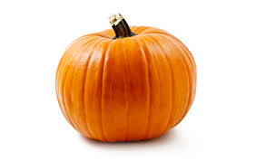
PUMPKIN RECIPE CONTEST
Sponsored By Center for Independence
When: October 7th– HARVEST FEST
Time: Drop off from 12:30pm-1:00pm & Judging @ 1:00pm
Where: Family Living Center, SD State Fairgrounds

Rules: Entry must contain pumpkin as an ingredient. Bring your entry with recipe attached to the Family Living Center between 12:30pm-1:00pm to get judged. Each dish will be assigned a number for judging. Judging will be at 1:00pm and awards to follow.
Your entry will be judged on taste, appearance and creative use of pumpkin.
Good luck and HAVE FUN! You are free to take your dish after judging. However, you are encouraged to sample the rest of your entry out to the public.
Prize Amounts:
1st Place - $50 in Huron Bucks
2nd Place - $30 in Huron Bucks
3rd Place - $20 in Huron Bucks

